PART V. DEVELOPMENT AND INVESTMENT PROGRAM

ICT PROJECTS IMPLEMENTATION SCHEDULE
NAME OF  ICT PROJECT/S | 2027 | 2028 | 2029 | REMARKS
- OFFICE PRODUCTIVITY |  |  |  | Procurement, maintenance
- EMERGING TECHNOLOGIES |  |  |  | Procurement
- NEXT-GEN SECURITY OPERATIONS CENTER (SOC) |  |  |  | Procurement
- SMART DIGITAL WORKPLACE (PHASE 2) |  |  |  | Procurement, implementation
- CONTINUING EXPENSES |  |  |  | Procurement, implementation

PART V. DEVELOPMENT AND INVESTMENT PROGRAM

- DIGITAL TRANSFORMATION INFORMATION SYSTEMS (IS) IMPLEMENTATION SCHEDULE
NAME OF INFORMATION SYSTEMS/SUB-SYSTEMS OR MODULES | 2027 | 2028 | 2029 | REMARKS
- DIGITAL TRANSFORMATION INFORMATION SYSTEM (IS)
- EXECUTIVE MONITORING AND MANAGEMENT SYSTEM
- HARMONIZATION OF ADMINISTRATIVE JUSTICE SERVICE SYSTEMS
- PUBLIC SECTOR EMPLOYEE ORGANIZATION MANAGEMENT SYSTEM
- INTEGRATED ELIGIBILITY AND EXAMINATION SYSTEM
- QUALITY MANAGEMENT SYSTEM (QMS)
- ENHANCEMENT OF HUMAN RESOURCE AND PAYROLL MANAGEMENT INFORMATION SYSTEM (FORMER NAME INTERNAL HUMAN RESOURCE INFORMATION SYSTEM)
- ENHANCEMENT OF INTERNAL AUDIT SYSTEM
- ENHANCEMENT OF HUMAN RESOURCE INVENTORY OF GOVERNMENT AGENCIES (FORMER NAME IGHRS)

PART V. DEVELOPMENT AND INVESTMENT PROGRAM
For an updated and relatively accurate cost estimate, CSC has conducted market study on the indicative costs of all proposed items reflected on this ISSP.

C. SUMMARY OF INVESTMENTS

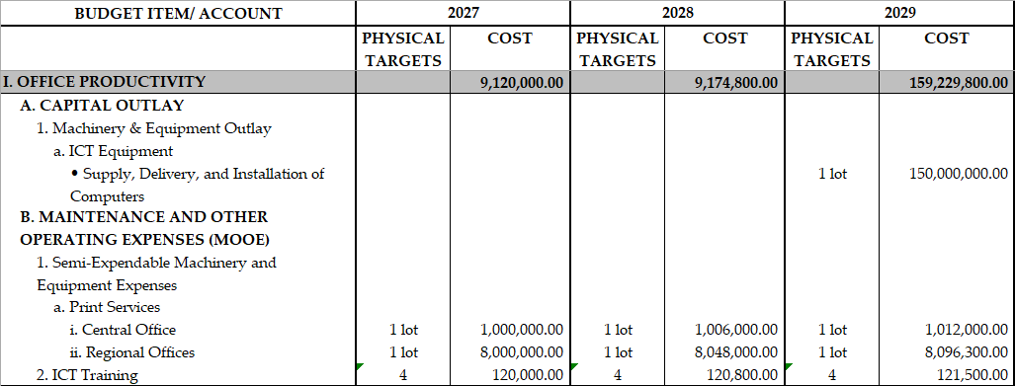
PART V. DEVELOPMENT AND INVESTMENT PROGRAM

C. SUMMARY OF INVESTMENTS

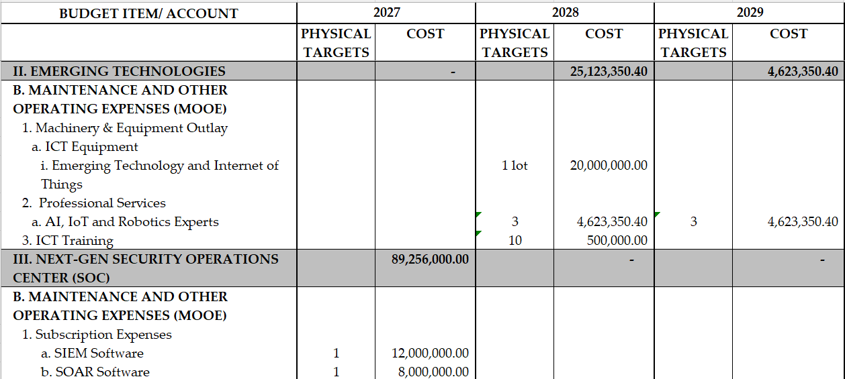
PART V. DEVELOPMENT AND INVESTMENT PROGRAM

C. SUMMARY OF INVESTMENTS

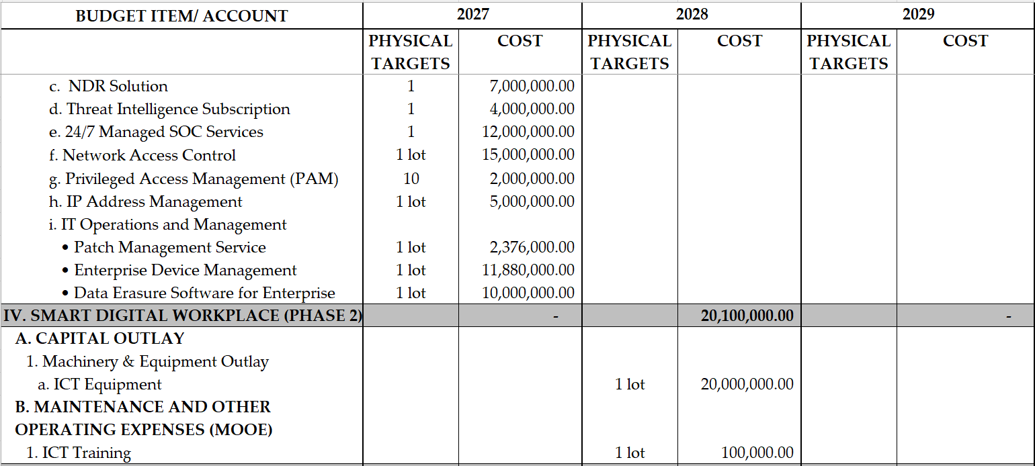
PART V. DEVELOPMENT AND INVESTMENT PROGRAM

- SUMMARY OF INVESTMENTS

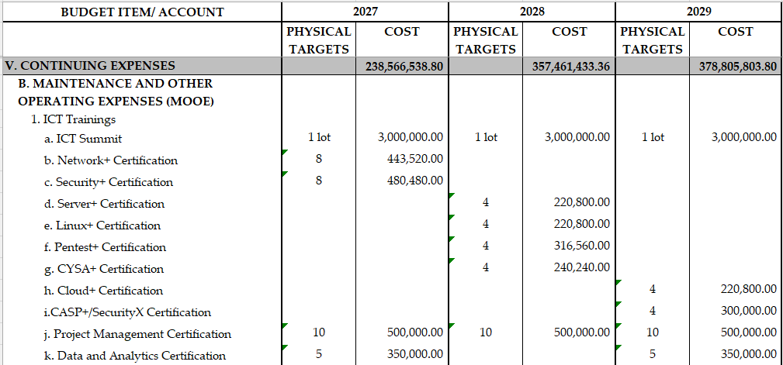
PART V. DEVELOPMENT AND INVESTMENT PROGRAM

C. SUMMARY OF INVESTMENTS

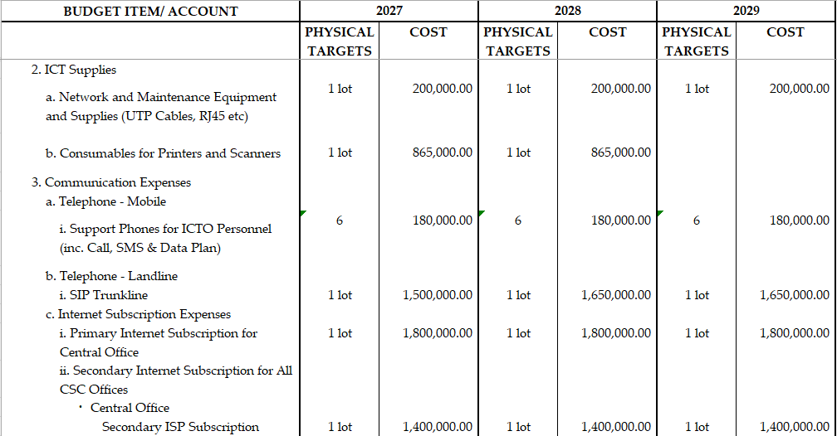
PART V. DEVELOPMENT AND INVESTMENT PROGRAM

C. SUMMARY OF INVESTMENTS

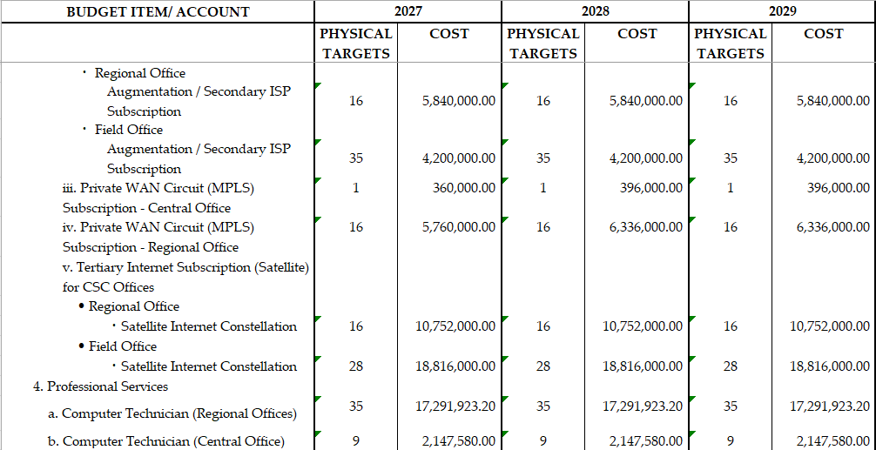
PART V. DEVELOPMENT AND INVESTMENT PROGRAM

C. SUMMARY OF INVESTMENTS

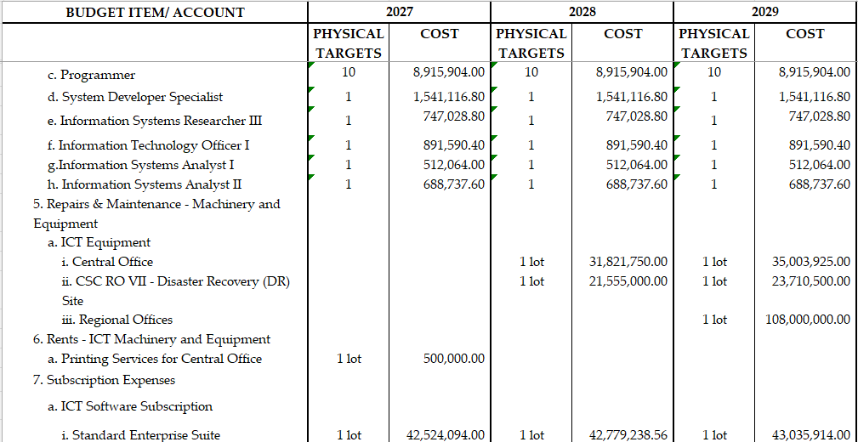
PART V. DEVELOPMENT AND INVESTMENT PROGRAM

C. SUMMARY OF INVESTMENTS

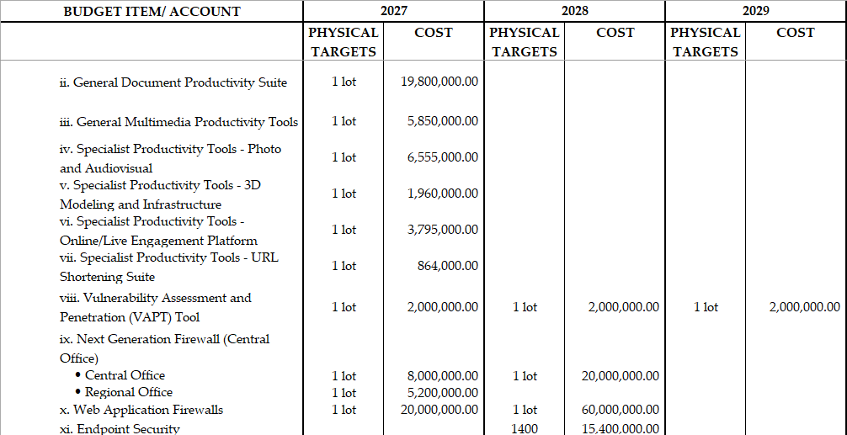
PART V. DEVELOPMENT AND INVESTMENT PROGRAM

C. SUMMARY OF INVESTMENTS

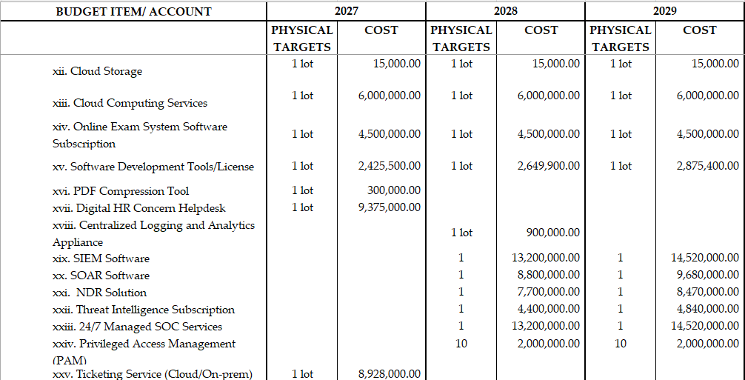
PART V. DEVELOPMENT AND INVESTMENT PROGRAM

C. SUMMARY OF INVESTMENTS

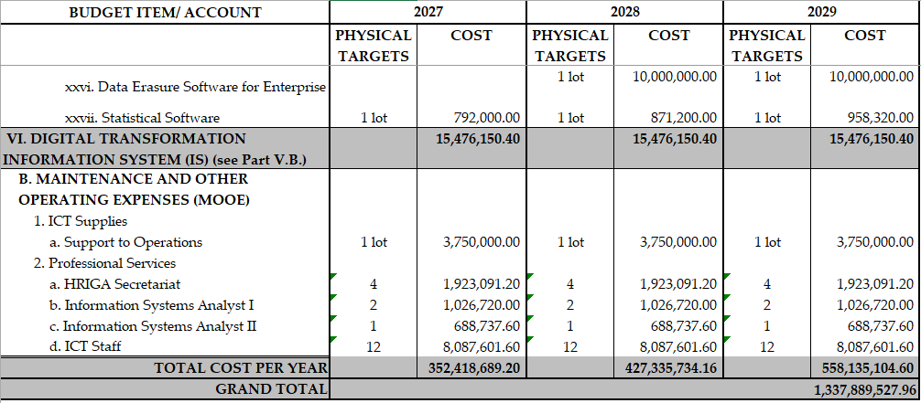

PART V. DEVELOPMENT AND INVESTMENT PROGRAM
D. YEAR COST BREAKDOWN (FY 2027-2029)
D.1 YEAR 1 COST BREAKDOWN (FY 2027)

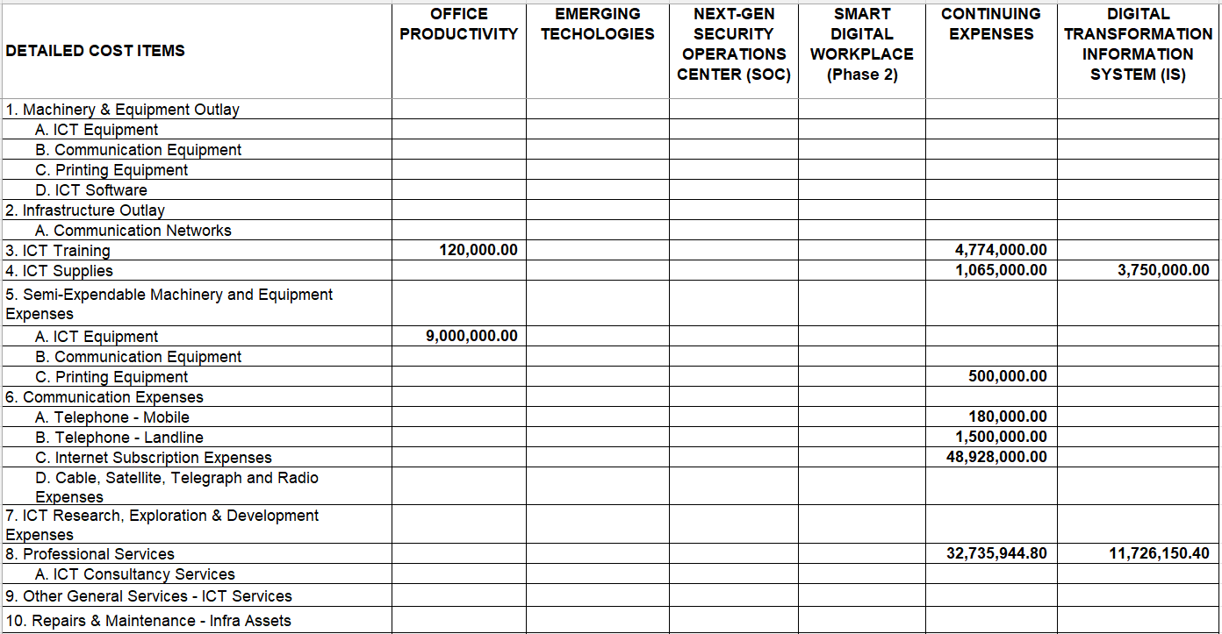
PART V. DEVELOPMENT AND INVESTMENT PROGRAM
D. YEAR COST BREAKDOWN (FY 2027-2029)
D.1 YEAR 1 COST BREAKDOWN (FY 2027)

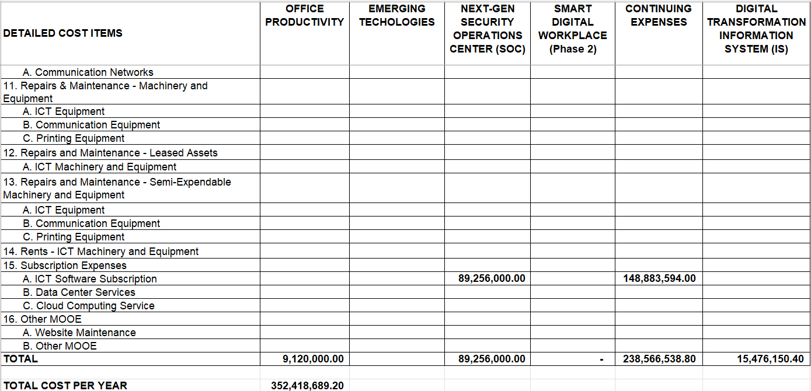
PART V. DEVELOPMENT AND INVESTMENT PROGRAM
D. YEAR COST BREAKDOWN (FY 2027-2029)
D.2 YEAR 2 COST BREAKDOWN (FY 2028)

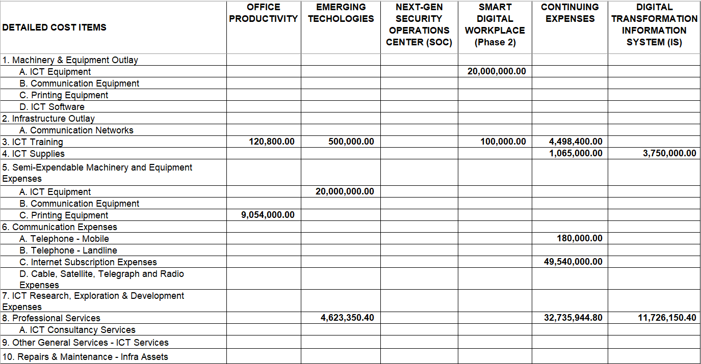
PART V. DEVELOPMENT AND INVESTMENT PROGRAM
D. YEAR COST BREAKDOWN (FY 2027-2029)
D.2 YEAR 2 COST BREAKDOWN (FY 2028)

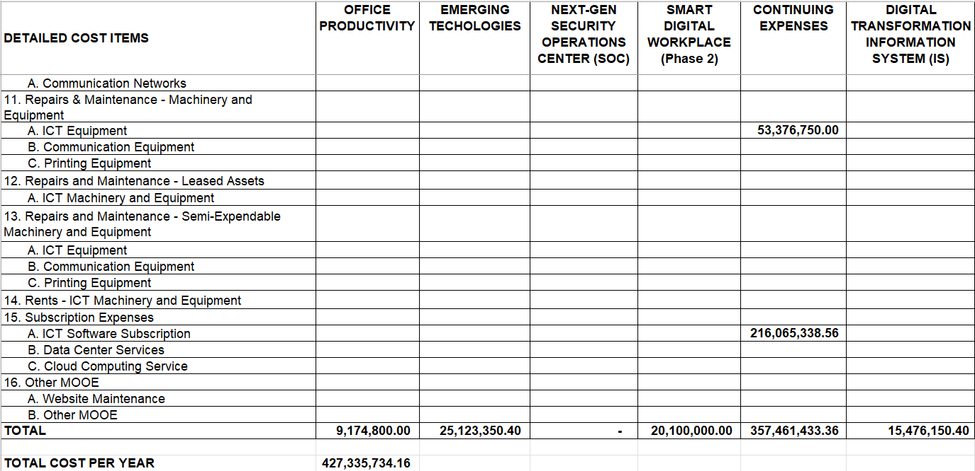

PART V. DEVELOPMENT AND INVESTMENT PROGRAM
D. YEAR COST BREAKDOWN (FY 2027-2029)
D.3 YEAR 3 COST BREAKDOWN (FY 2029)

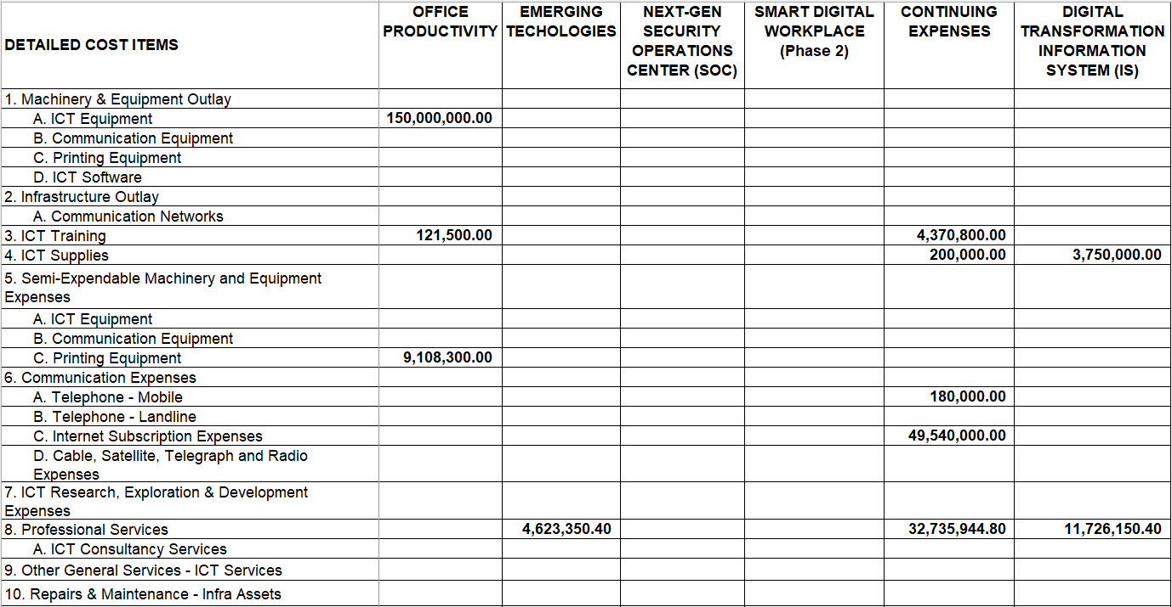
PART V. DEVELOPMENT AND INVESTMENT PROGRAM
D. YEAR COST BREAKDOWN (FY 2027-2029)
D.3 YEAR 3 COST BREAKDOWN (FY 2029)

